**Data Set Title**

**Exploratory Analysis**

Connor Goodman, cgoodman2@bellarmine.edu

1. **INTRODUCTION**

This data set is League of Legends Worlds 2021 Event Stats from and can be found online on Kraggle and originally posted on Reddit. I am the eSports administrator for Bellarmine University and enjoy League of Legends so I thought seeing data collected from the world championships would be interesting and a great source of a lot of data.

1. **DATA SET DESCRIPTION**

This data set contain 220 rows of data and 20 columns of different data types. The following table (Table 1) is a list of those columns and data types.

**Table 1: Data Types**

|  |  |  |
| --- | --- | --- |
| *Variable Name* | *Data Type* | *Missing Data (%)* |
| Team | Nominal / object | 0% |
| Player | Nominal / object | 0% |
| Opponent | Nominal / object | 0% |
| Position | Nominal / object | 0% |
| Champion | Nominal / object | 0% |
| Kills | Ratio / int64 | 0% |
| Deaths | Ratio / int64 | 0% |
| Assists | Ratio / int64 | 0% |
| Creep Score | Ratio / int64 | 0% |
| Gold Earned | Ratio / int64 | 0% |
| Champion Damage Share | Ratio / float64 | 0% |
| Kill Participation | Ratio / float64 | 0% |
| Wards Placed | Ratio / int64 | 0% |
| Wards Destroyed | Ratio / int64 | 0% |
| Ward Interactions | Ratio / int64 | 0% |
| Dragons For | Interval / int64 | 0% |
| Dragons Against | Interval / int64 | 0% |
| Barons For | Interval / int64 | 0% |
| Barons Against | Interval / int64 | 0% |
| Result | Ordinal / object | 0% |

1. **Data Set Summary Statistics**

All Categorial data stats that are integers that can be complied are listed in Table 2#.

**Table 2: Summary Statistics for LoL Worlds 2021**

|  |  |  |  |  |  |  |
| --- | --- | --- | --- | --- | --- | --- |
| *Variable Name* | *Count* | *Mean* | *Standard Deviation* | *Min* | *Max* | |
| Kills | *13* | *2.701* | *2.58* | *0* | *13* |
| Deaths | *8* | *2.72* | *1.75* | *0* | *7* |
| Assists | *18* | *5.67* | *3.89* | *0* | *19* |
| Creep Score | *149* | *200.34* | *101.33* | *14* | *419* |
| Gold Earned | *215* | *11008.16* | *3198.81* | *4714* | *20546* |
| Champion Damage Share | *38* | *.2* | *.01* | *.04* | *.47* |
| Kill Participation | *62* | *.601* | *.19* | *0* | *1* |
| Wards Placed | *42* | *19.5* | *15.7* | *3* | *92* |
| Wards Destroyed | *24* | *8.7* | *5.1* | *1* | *30* |
| Ward Interactions | *58* | *28.16* | *18.05* | *7* | *112* |
| Dragons For | *5* | *2.09* | *1.38* | *0* | *4* |
| Dragons Against | *5* | *2.09* | *1.38* | *0* | *4* |
| Barons For | *3* | *.55* | *.66* | *0* | *2* |
| Barons Against | *3* | *.55* | *.66* | *0* | *2* |

Table 3: Proportions for LoL Worlds 2021

|  |  |
| --- | --- |
| *Variable Name* | *Frequency* |
| Kills | 55 |
| Deaths | 48 |
| Assists | 29 |
| Creep Score | 5 |
| Gold Earned | 2 |
| Champion Damage Share | 15 |
| Kill Participation | 15 |
| Wards Placed | 18 |
| Wards Destroyed | 24 |
| Ward Interactions | 14 |
| Dragons For | 55 |
| Dragons Against | 55 |
| Barons For | 120 |
| Barons Against | 120 |

1. **DATA SET GRAPHICAL EXPLORATION**

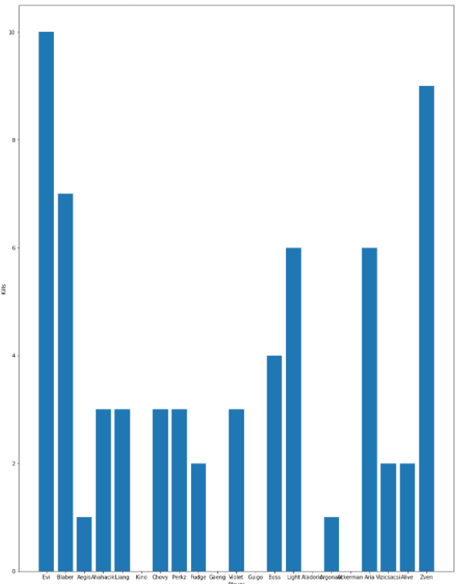

Each pro player’s individual kill amount in bar graph using Matplot.

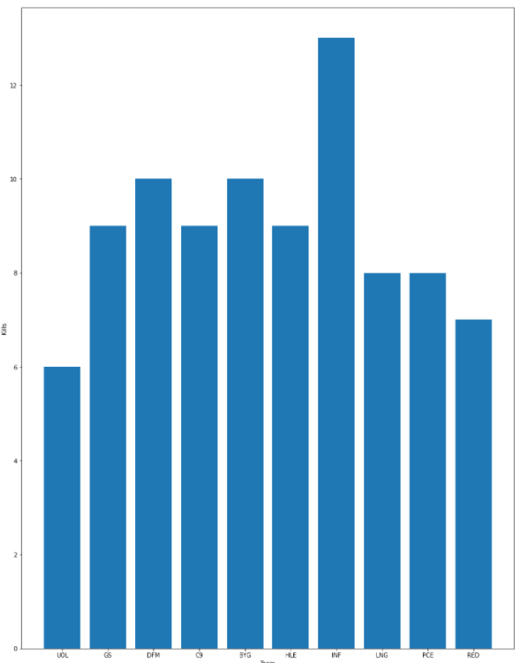

Total Kills for each team bar graph using matplot.

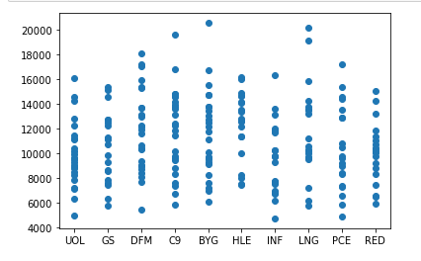

Scatter plot for team gold amounts for each game there is one plot using Matplot.

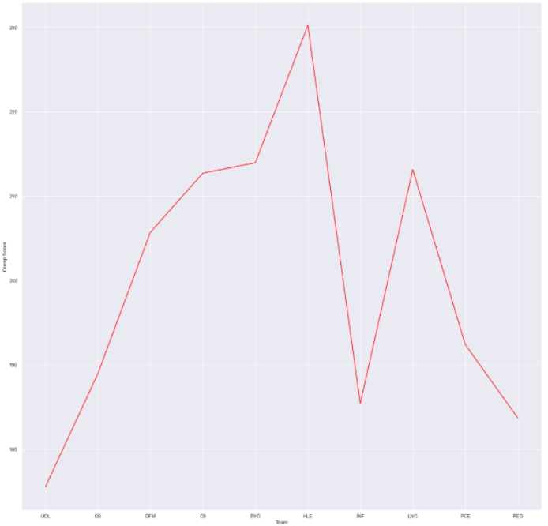

Seaborn graph showing Team creep score for all comp teams.

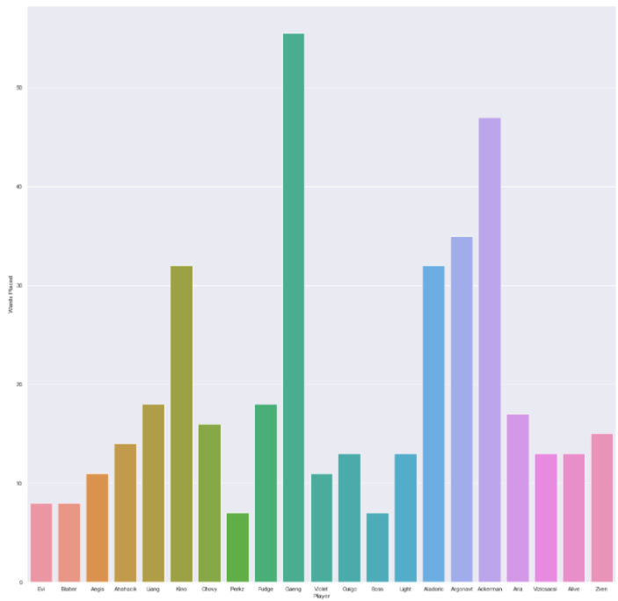

Seaborn bar graph for Set of random players to show wards placed for an average data overall.

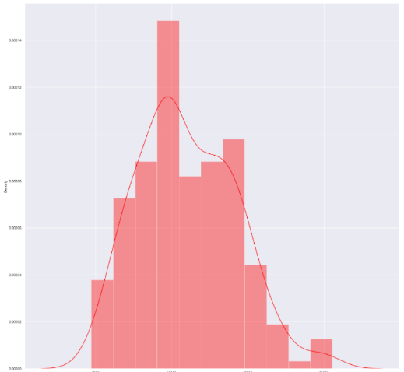

Seaborn histograph for average game time gold earning trackage with amount over time played.

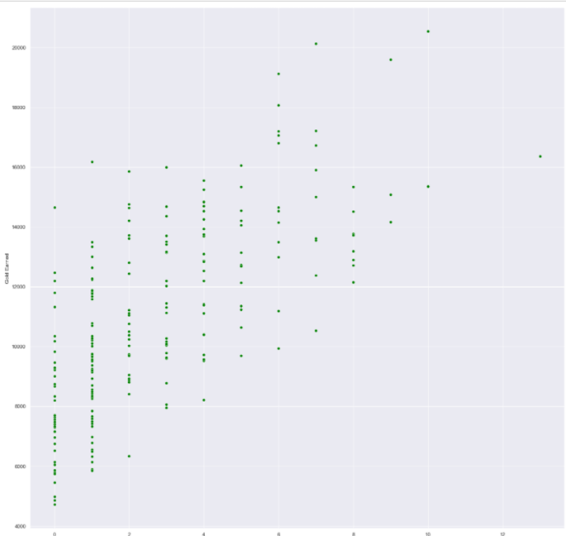

Seaborn scatterplot for kill number amounts correlation to average player gold amounts.

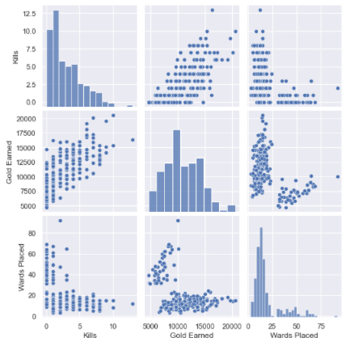

Seaborn pair plot for Wards Placed, Gold Earned, and Kill amounts to give a wide variety of graphing for ease of access to information.